**UnmixColors**

UnmixColors creates separate images per dye stain for histologically stained images.

This module creates separate grayscale images from a color image stained with light-absorbing dyes. Dyes are assumed to absorb an amount of light in the red, green and blue channels that increases proportionally in each channel with increasing amounts of stain; the hue does not shift with increasing staining. The module separates two or more stains, producing grayscale images that look similar to fluorescent images and thus can be analyzed similarly. There are several pre-set dye combinations; since the exact dye appearance can vary between users and due to issues such as lighting conditions, there is also a custom mode that allows you to calibrate how your dyes look in your exact tissue. Some commonly known stains are actually mixes of 2 or more dyes and thus must be specified by all of their individual dye components.

For example:

* Hematoxylin-Eosin: Hematoxylin + Eosin
* Giemsa: Methylene Blue + Eosin

**Note:** Mixes of single color fluorescent images should be unmixed with the **ColortoGray** module.

**Technical notes:**

This module is adapted from the ImageJ plugin, Colour_Deconvolution.java written by A.C. Ruifrok, whose paper forms the basis for this code.

**Goals of this exercise:**

In this exercise, we will guide you to separate stained samples through the UnmixColors module using reference absorbances and calculate your absorbance in the Custom mode.

**Materials necessary for this exercise:**

* Histopathological image of parathyroid adenoma. Hematoxylin and eosin stain in a slide.

**Example 1:** Parathyroid Adenoma

/…/Input/Exampe1Parathyroid_Adenoma.jpg

**Example 2:** Parathyroid Adenoma

/…/Input/Example2Parathyroid_adenoma.jpg

**Importing data in CellProfiler**

1. Highlight the **Images** module.

2. Drag-and-drop the Example 1 image only into the Images module window.

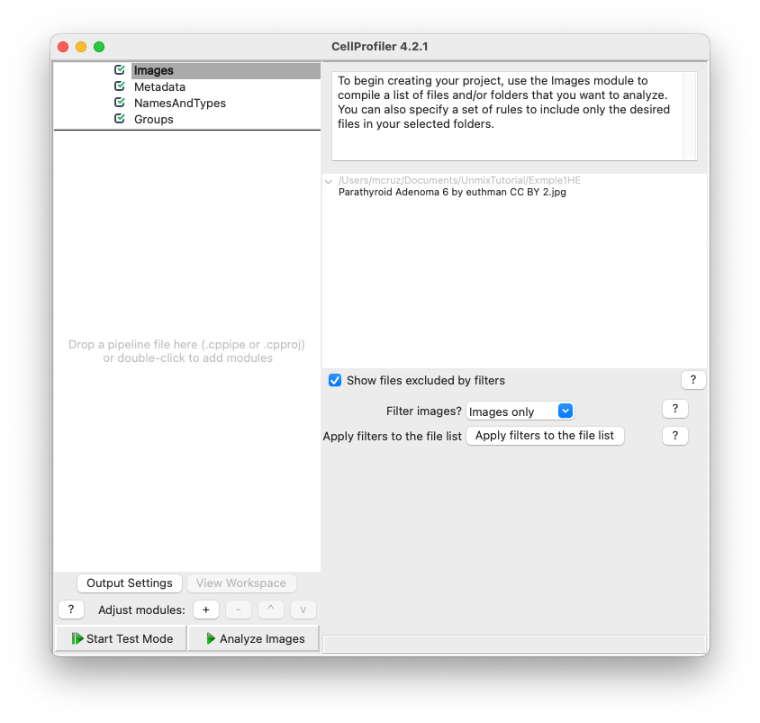

3. Highlight the **NameAndType** module.

Assign a name to: All images

Select the image type: Color image

1. Assign the images “variable names” that describe the contents in the image. For example, use the name "HE" or "Hematoxylin-Eosin" or something else that will remind you what the image is.
2. Hit the "update" button to populate

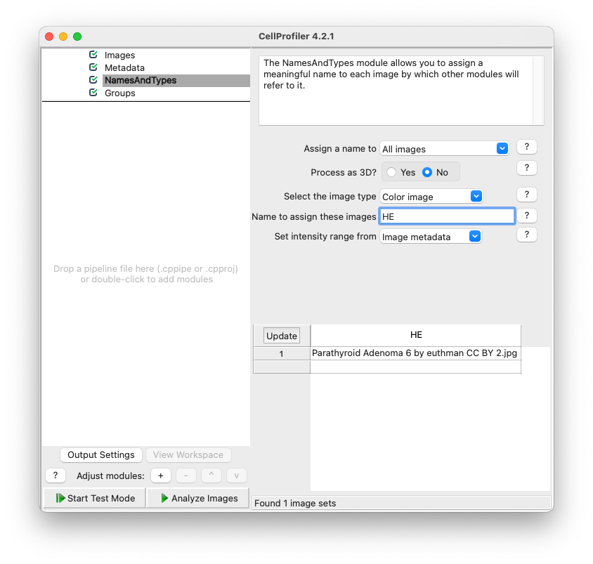

**UnmixColors module:**

Add the **UnmixColor** module to the pipeline. Double click or right click on the white rectangular area below Groups or click the + button in front of the Adjust modules, this pops up the Add modules window, search the **UnmixColors** module and double click in it.

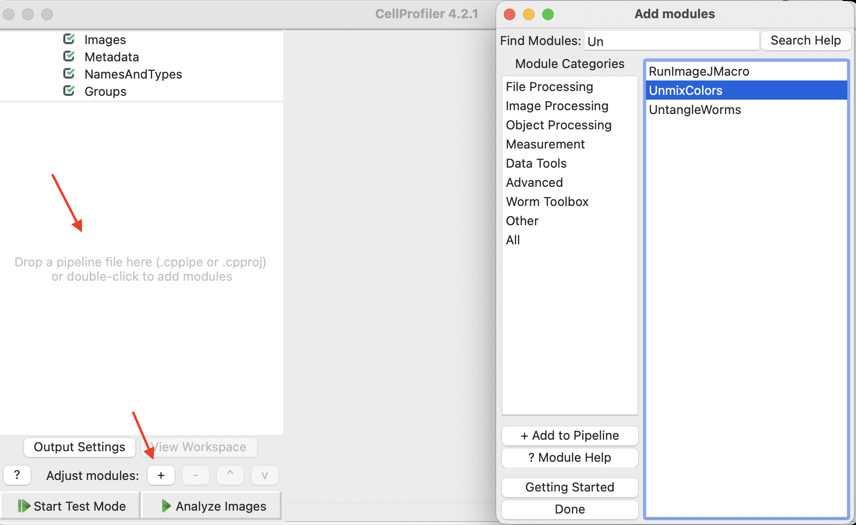

Using the **UnmixColors** module, try to separate the hematoxylin from the eosin staining in this new example.

* Select the input color image: HE (or whatever the name you give for your images in **NamesAndTypes** module)
* Name the output image as Hematoxylin
* Choose the Stain as Hematoxylin
* Add another stain
* Name this new output image as Eosin
* Choose the Stain as Eosin

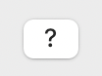

**Tip: Use the question mark button to learn more or if you have questions.**

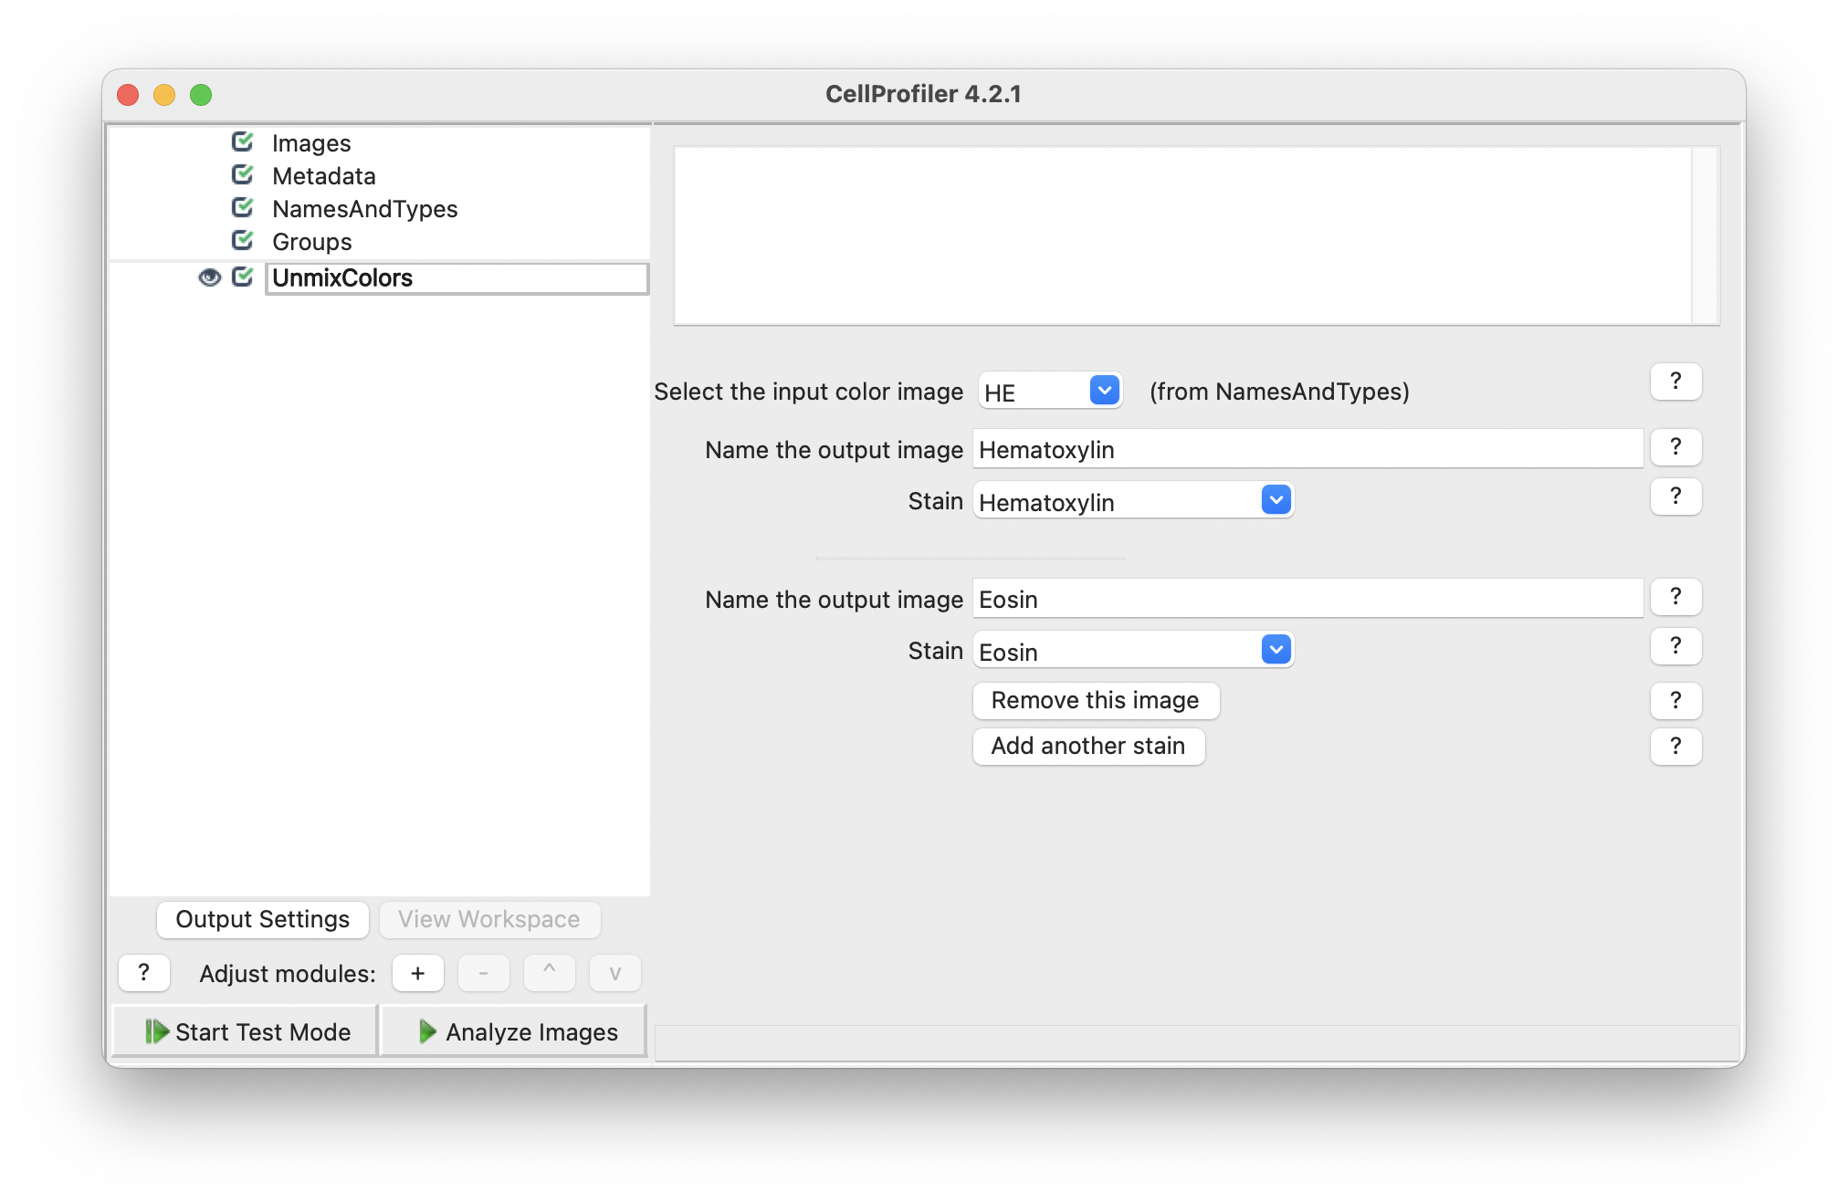

Start Test Mode (left bottom of the window) and Test your **UnmixColor** module pressing the Step button. The result of the **UnmixColors** module should pop-up and show you a Hematoxylin image (Nucleus) and an Eosin image (cytoplasm).

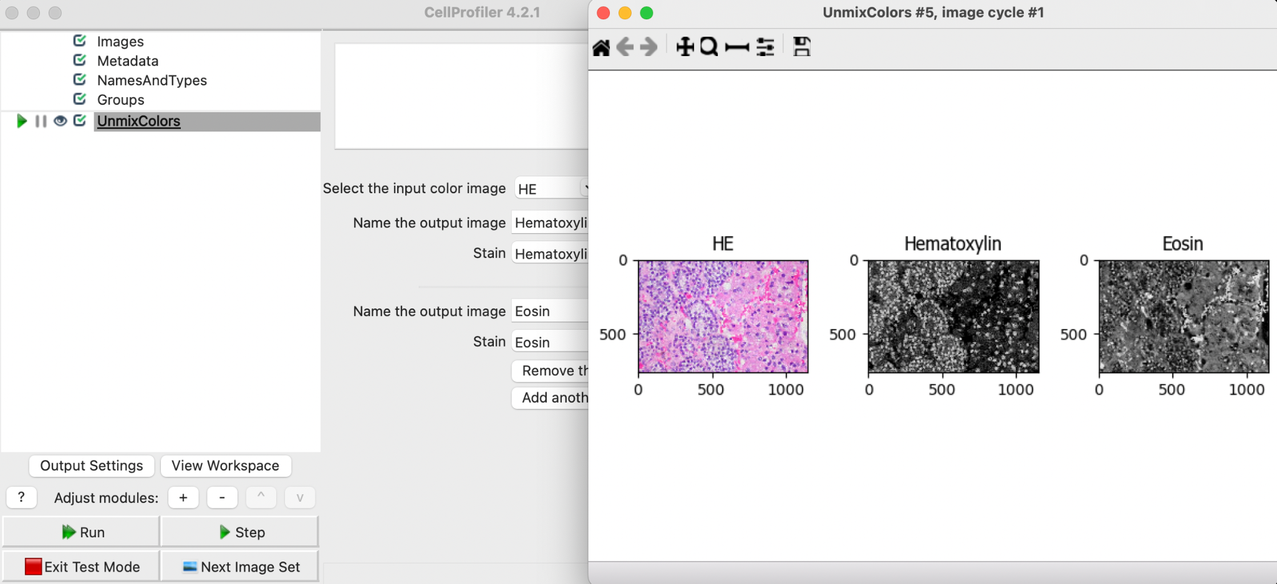

**Note:** If there are other cells/components that you also want to separate by color, choose the stain that most closely resembles the color you want. Please note that if you are looking to simply split a color image into red, green and blue components, use the **ColorToGray** module rather than **UnmixColors**. The question mark button to the right of Stain can help you choose the correct Stain.

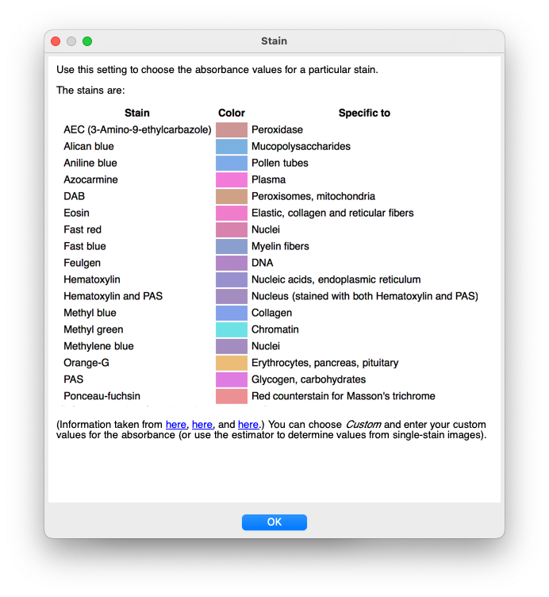

**Tip: The image tools on the top toolbar may be helpful to see the details on your image/objects:**

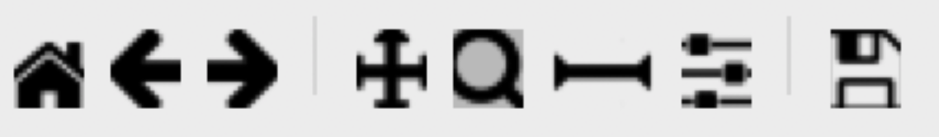

The 1st icon from the left lets you reset the view back to the original view.

The 2nd and 3rd icons let you step backwards and forwards through any changes you made to the view.

The 4th icon lets you change the view by moving in any direction in the display, by clicking and dragging.

The 5th icon lets you change the view by zooming, by dragging and drawing a box to zoom in on.

Zoom in on the image in order to see the quality of the separation.

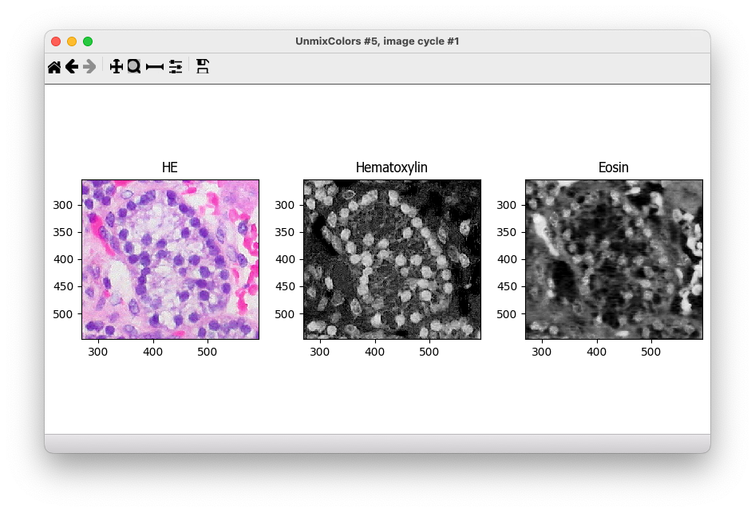

Most of the time the Stain settings does a good job with the standard Stain, but If you are not happy with your results you can try different combinations of stains to match the structure/color you want to segment later.

For example:

Right click the **UnmixColors** module and Duplicate the module in your pipeline.

Change the Hematoxylin stain for Feulgen Stain and the Eosin Stain for Azocarmine. (remember to rename the output images to stay Hematoxylin and Eosin)

Observe the difference between the first and the second separation.

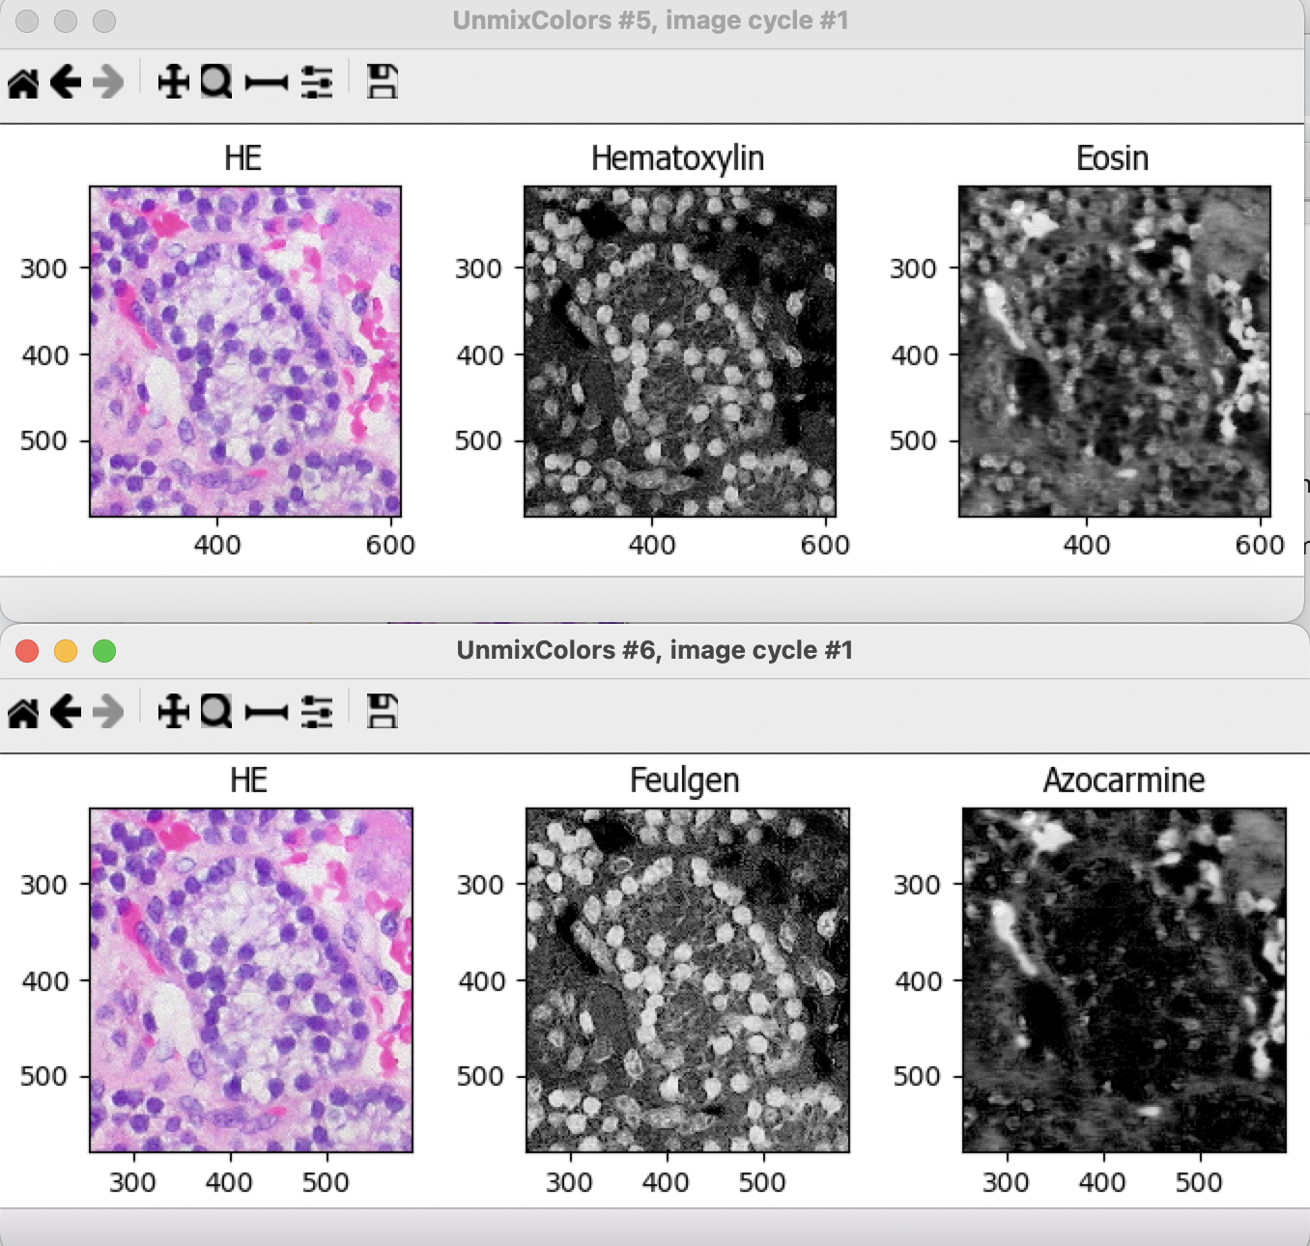

**Now let’s try another example of the same type of tissue and staining (Example 2 image):**

Please go back to your **Images** Module

1. Clear the file list (Right click inside the file box -> click in the last option Clear File List)

2. Drag and drop the Example 2 image.

Hit run to run your two **UnmixColors** modules to try to separate the hematoxylin from the eosin staining in this new example.

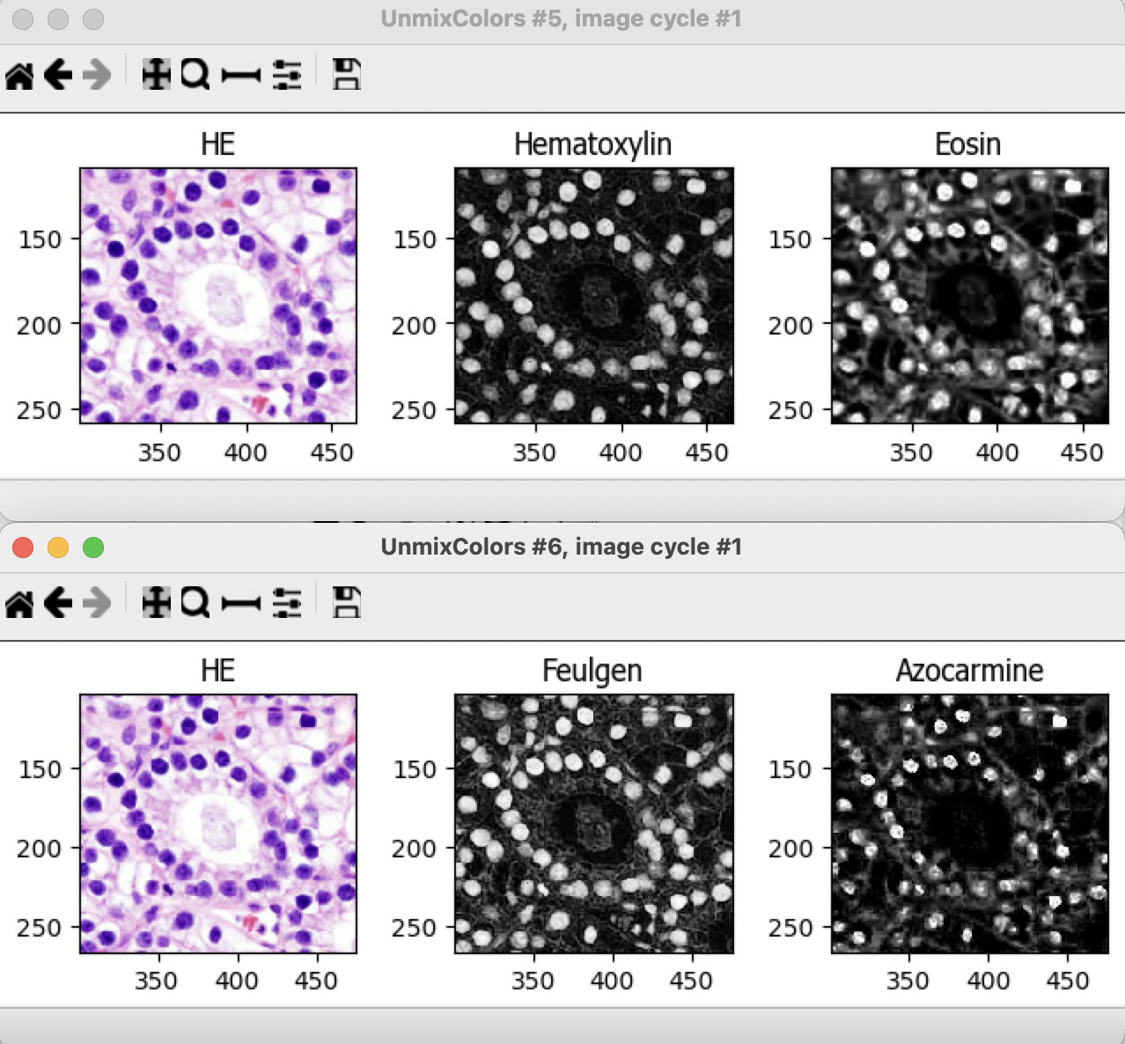

**Common issue and troubleshooting:**

Sometimes the same kind of tissue stained in different days or acquired in different illumination conditions will produce different patterns of absorbance and none of the Stain combinations results in a proper stain separation even in slides of similar tissues stained with the same dyes.

If this happens, you can try other combinations, or choose the custom Stain option. In this case there are two options, input the RGB absorbance values if known or, far more commonly, estimate it using small cropped image regions where only one of your stains is present (region that contains the color absorbance of interest, purple and pink in this image).

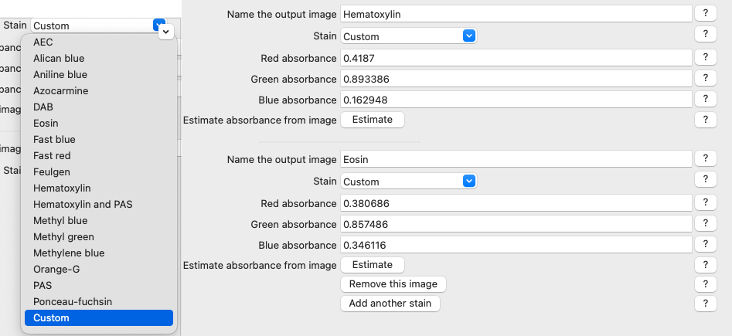

If you choose the second option, we suggest you make the cropped absorbance images in FIJI. (Open your image in FIJI, zoom in the region of interest and duplicate small regions where only one of your stains is present [in this case, one purple and another pink region] and save these images);

While we encourage you to do this step yourself in FIJI, we do provide reference images you can try (UnmixColorsTutorial/CustomReferenceImages/)

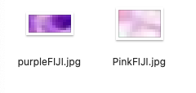

CellProfiler can then use this to estimate your RGB absorbance.

Inside the **UnmixColors** module when you choose the **Custom Stain** option a new option will appear, the ‘Estimate absorbance from image’ button, so you can click on it and choose the purple or pink image to estimate the RGB absorbance. Cell Profiler will automatically calculate the absorbance for you.

After Estimate both Stains you can now test the color separation using the Test Mode.

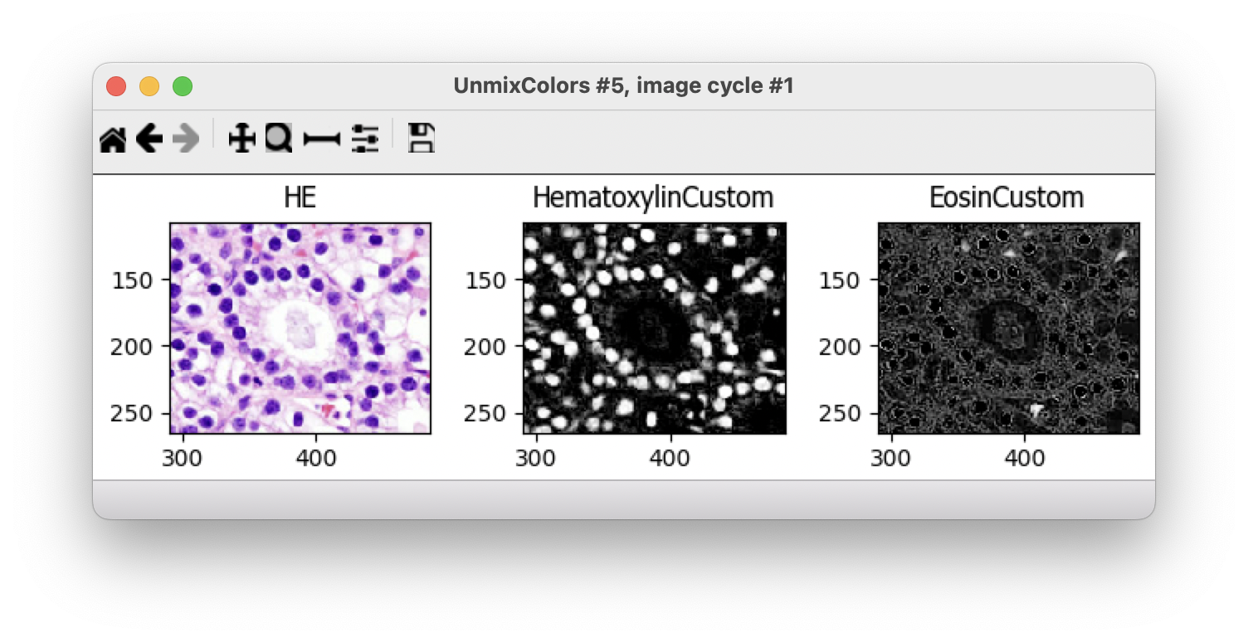

**Note:** If the resulting image doesn’t match your expectation you can try again using other regions to estimate your RGB absorbance.

**Congratulations, you finished the Unmix Colors Tutorial.**

**References:**

<https://cellprofiler-manual.s3.amazonaws.com/CellProfiler-4.2.1/modules/imageprocessing.html>

Ruifrok AC, Johnston DA. (2001) “Quantification of histochemical staining by color deconvolution.” Analytical & Quantitative Cytology & Histology, 23: 291-299.

**Images sources:**

Example 1: Parathyroid Adenoma 6 by euthman.jpg ([CC 2.0](https://creativecommons.org/licenses/by/2.0/), 1148 x 765 pixels, file size: 441 KB, https://www.flickr.com/photos/euthman/4703621316/in/photolist-8aDhKf)

Example 2: Parathyroid_adenoma_histopathology_(2).jpg ‎([CC 3.0-SA](https://creativecommons.org/licenses/by-sa/3.0/deed.en), 600 × 452 pixels, file size: 172 KB, https://commons.wikimedia.org/wiki/File:Parathyroid_adenoma_histopathology_(2).jpg)